STRETCHING
It is suggested that with just about all forms of physical activity a warm up should be included in the pre-exercise routine. Warm ups should include light exercise for 5-15min, should be sport specific and can include stretching.
Types of stretch: Injury prevention and performance can depend on the type of stretch used, there are 3 main types: Static- where you stretch a muscle to the point of discomfort and hold, Dynamic- where you rhythmically move a part of the body to stretch a muscle gradually increasing the range and PNF (proprioceptive neuromuscular facilitation)- where someone helps you stretch, then you push into them and as you relax they push you back into a greater stretch.
Injury prevention: In terms of injury prevention all forms of pre participation stretching do not increase the prevalence of injury. When we break that down to injuries such as muscle strains, tendon strains and related injuries we see that static and dynamic stretching can have an effect on reducing injury rates. Stretching before or after exercise does have an effect in reducing DOMS (Delayed Onset Muscle Soreness- that achy muscle feeling you usually get 2 days after a good workout!).
If you have a pre-existing injury stretching can help in reducing the risk of recurrence of a similar injury, which is why physio’s love our stretches! Research has shown that over the long term increasing the length of specific muscles has shown a decrease in sports injuries and an increase in performance.
Effect on performance: One of the reasons people have shied away from stretching is that some articles have reported that it was bad for you. Studies have shown that stretching before sport can slightly reduce sprint and jump performance. For most players the effects are largely negligible, but if you are worried about it use dynamic stretching beforehand (no effect on performance) and use static stretching afterwards. Some sports such as golf actually increase performance after dynamic stretching!
Why we stretch:
- Injury prevention of muscle/tendon injuries
- Prevent Delayed Onset Muscle Soreness (DOMS)
- Prevents Recurrence of injury
- Dynamic stretch doesn’t decrease and can increase Performance!

Take home messages:
- Overall the most important message is to make sure you are completing an adequate warm up before exercise followed by your dynamic stretches
- In the long term a flexible muscle will reduce the instance of injury. Incorporate dynamic stretching into the warm up and statically stretch afterwards.
- Stretching should be tailored to the exercise about to be performed and to incorporate individual differences.
- To further reduce the risk of injury remember that stretching works best in conjunction with warm up, adequate footwear, appropriate playing surface, skills training, appropriate protective equipment e.t.c.
- If you have been given a stretching program due to an injury it is important to follow it to help prevent recurrence.
If you have any questions regarding stretches please contact us!

DYNAMIC STRETCHING
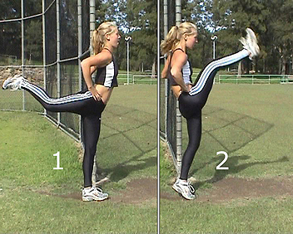
Dynamic stretches seem to be more effective at reducing muscle stiffness, which is thought to increase the likelihood of muscle tears. For this reason, many coaches now advocate static stretching after cool down to increase range of motion, and dynamic stretching prior to performing for injury prevention and preparation. Dynamic stretches should be performed for 2 sets of 12-16 repetitions, gradually increasing range until full range has been achieved.
- Flexion/Extension- Stand sideways onto the wall
- Weight on your left leg and your right hand on the wall for balance
- Swing your right leg forward and backward
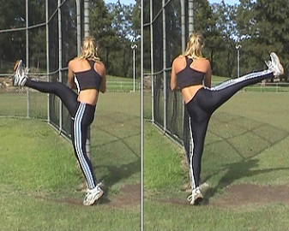
- Cross-Body flexion/Abduction - Leaning slightly forward with both hands on a wall and your weight on your left leg, swing your right leg to the left in front of your body, pointing your toes upwards as your foot reaches its furthest point of motion
- Then swing the right leg back to the right as far as comfortable, again pointing your toes up as your foot reaches its final point of movement
- Hip Hurdles- Starting position standing with one knee bent to 90 degrees
- Circle the hip in an outwards direction.

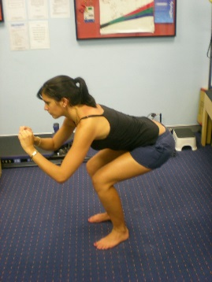

- Squats- Standing tall both feet together (starting position)
- Keep the back straight, bend both knees and drop into a squat.

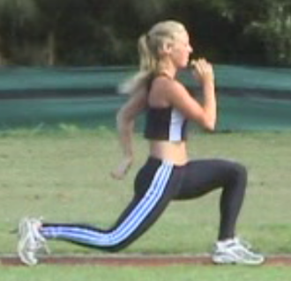
- Lunges- Standing tall both feet together (starting position)
- Keeping the back straight lunge forward with the right leg approx 1 to 1½ metre
- The right thigh should be parallel with the ground and the right lower leg vertical
- Spring back to the starting position
- Repeat with the left leg
- 12 to 16 repetitions on each leg

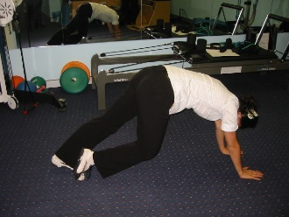
Ankle Bounce- Start position is both hands on the ground and standing on both toes.

Gently lower one heel to the ground.

Alternate with the opposite foot.

STATIC STRETCHING

Static stretches have been proven to be one of the most effective ways to a lengthen a muscle. This can effectively reduce the instance of muscle and tendon strains. As such they are still considered essential as part of any sport, exercise regime or rehab program. Static stretches should be conducted after an effective cool down or as part of a daily routine.
Only stretch a cold muscle if you are not about to participate in exercise within 15min. If you are given stretches as part of a rehab program these should ideally be done daily or more often as directed. Typically stretches will be 3 sets of 30sec for each side. Some static stretches useful for most sports are included below, your physio made add stretches depending on your sport and individual needs.
- Calf Stretches
Stand on a yellow pages book and push heels firmly into the ground. Repeat the stretch with straight and bent knees.
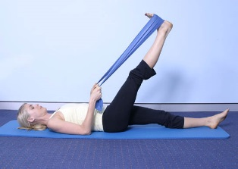

- Hamstring Stretch
Lie on the floor. Use a belt, towel or a Theraband around the foot to lift the leg as high as you can (stop when you feel a strong stretch at the back of the knee). It is important to keep the leg straight.
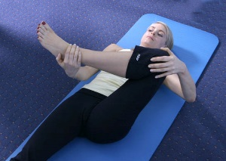
- Gluteal Stretch
Form a “figure of four” with your hip flexed to 90degress and your foot pointing across your body. Pull the leg towards your chest.

- Hip Flexor Stretch
Kneel on the floor with the one leg stretched out behind you. Lift both arms to the ceiling and lean away from the back leg.

- Groin Stretch
Sitting, pull both heels inwards towards your groin. Try and get the knees as close to the ground as possible. Keep your back straight.
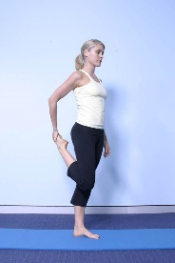
- Quads Stretch
In standing bend your knee behind you and pull your heel toward your buttocks, now bring your knee slightly backwards and push your hips forwards. You should feel the stretch coming down the front of the thigh.

- Lower Back Stretch
Lying with both knees bent. Cross the right leg over the left leg and drop both knees to the left (get the knees to touch the floor). Open the right arm out to the right side and look towards the right. Repeat in the opposite direction.

