**Hydration in Sport**

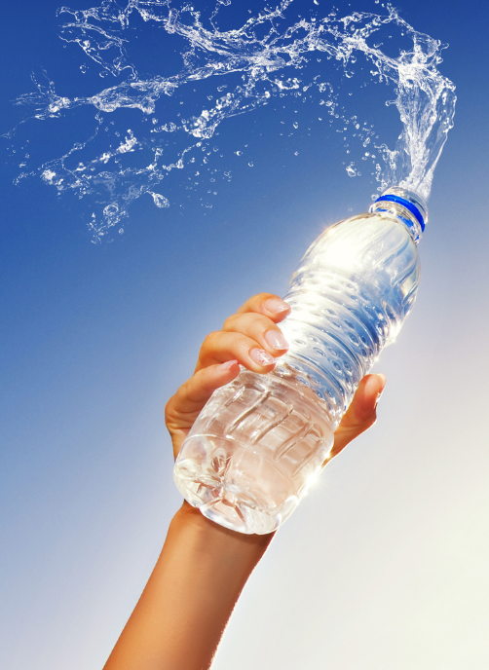Water is essential to maintain blood volume, regulate body temperature and allow muscle contractions to take place. During exercise, the main way the body maintains optimal body temperature is by sweating.  Heat is removed from the body when beads of sweat on the skin evaporate, resulting in a loss of body fluid. This increases with a rise in ambient temperature and humidity, as well as with an increase in exercise intensity.  
  
Drinking fluid during exercise is necessary to replace lost sweat, as well as reduce the risk of heat stress, maintain normal muscle function, and prevent performance decreases due to dehydration. In most cases during exercise the rates of sweat loss are higher than the rate you can drink, so most athletes get into fluid deficit. However it is also possible to over-hydrate. This guideline promotes appropriate fluid intake during sport.

**The Dangers of Dehydration**  
  
Dehydration reduces physical and mental performance. It causes an increase in heart rate and body temperature, which means your body has to work harder than it already is. Your perception of how the exercise feels changes so that it seems harder.

Studies show that loss of fluid equal to 2% of body mass is sufficient to cause a significant decrease in performance (that’s a 1.4 L loss in a 70 kg athlete).  
  
Dehydration of greater than 2% loss of body weight increases the risk of nausea, vomiting, diarrhoea, and other gastro-intestinal problems during exercise.  
  
Dehydration reduces the rate of fluid absorption from the intestines, making it more difficult to reverse the fluid deficit. You may end up feeling bloated and sick if you delay fluid replacement. Nausea, vomiting, diarrhoea, and other gastro-intestinal problems may occur with more severe dehydration levels.  
 

**The Dangers of Over-hydration**  
  
Over-hydration also affects both physical and mental performance. Too much fluid can cause a dilution of blood sodium levels (hyponatraemia). Symptoms include headaches, disorientation, coma, and in severe cases, death. Over-hydration commonly occurs in colder weather or when the exercise pace is gentle, and the rate of sweat loss may be quite low.

**Estimating Your Fluid Loss**  
  
Weigh yourself before and after the session, using accurate scales. If possible, weigh naked or in minimal clothing, and be sure to towel dry any excess sweat (so you are not weighing sweat lost into your clothing). Your weight change during exercise reflects your total fluid loss; i.e. the difference between your sweat losses and fluid intake. As a general rule, aim to keep this weight loss less than 1kg. (1kg = 1 litre of fluid)

**Staying Hydrated**  
  
As a general rule, 250mL of water should be consumed every 15mins of exercise. More or less fluid, however, may be required depending on factors such as the weather and the intensity of the exercise.   
  
During high intensity exercise, where carbohydrates are lost in addition to fluid loss, a sports drink that contains electrolytes can speed up the re-hydration process. This is due to the coactivation of glucose and sodium molecules. Hydralyte is a good choice due to its electrolyte and low sugar content.

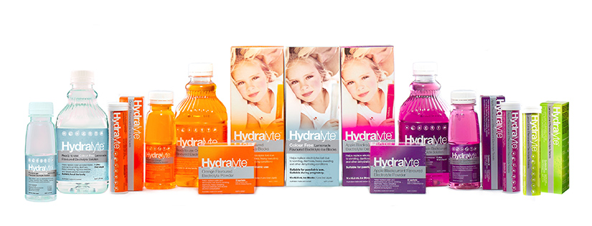

Re-hydrating post-exercise is necessary since fluid loss continues due to sweating and urination. Plan to replace 150% of your fluid deficit over the next 2-6 hours. For example, if you lost 1 kg (1000 mL), you will need to drink 1500 mL to fully re -hydrate. The image below, obtained from ylmsportscience, provides a guideline for adequate re-hydration.

